
Establishing Common-use Supply Arrangements

July 2023

Guide
Establishing Common-use Supply Arrangements


Department of Energy and Public Works Version 1 July 2023

Establishing Common-Use Supply Arrangements
V1 July 2023

The State of Queensland (Department of Energy and Public Works) 2023
http://creativecommons.org/licenses/by/4.0/deed.en
This work is licensed under a Creative Commons Attribution 4.0 Australia Licence. You are free to copy, communicate and adapt this work, as long as you attribute by citing ‘Establishing Common-Use Supply Arrangements’, State of Queensland (Department of Housing and Public Works) 2018’.

Contact us
Queensland Government Procurement is committed to continuous improvement. If you have any suggestions about how we can improve this guide, or if you have any questions, contact us at betterprocurement@epw.qld.gov.au.
Disclaimer
This document is intended as a guide only for the internal use and benefit of government agencies. It may not be relied on by any other party. It should be read in conjunction with the Queensland Procurement Policy, your agency’s procurement policies and procedures, and any other relevant documents.
The Department of Energy and Public Works disclaims all liability that may arise from the use of this document. This guide should not be used as a substitute for obtaining appropriate probity and legal advice as may be required. In preparing this document, reasonable efforts have been made to use accurate and current information. It should be noted that information may have changed since the publication of this document. Where errors or inaccuracies are brought to the attention of the Department of Energy and Public Works, a reasonable effort will be made to correct them.

Contents

Associated policy 4
Guideline 4
Principles 4
Research and collaborate 4
Category Council Approval 5
Planning 5
The Procurement Process 5
References 5
Process map 6
Process map 7

Associated policy
The easiest way to buy for government is to use an existing whole-of-government, common-use supply arrangement, such as a standing offer arrangement (SOA) or preferred supplier panel (PSP).
These arrangements provide cost-effective and efficient ways to buy products and services.
Clause nine of the Queensland Procurement Policy - 2023 states that common-use supply arrangements must be used unless one of the following situations applies:
  - the delivery area is regional or remote, and there are no capable and competitive ‘local suppliers’ on the arrangement
  - the ‘procurement’ activity directly supports a relevant government economic, ethical, social and environmental objective or target set out in Principle 1, and cannot be met using the arrangement.
This guide describes some practical steps and advice about establishing, managing, and avoiding the duplication of supply arrangements.

Guideline

Principles
Following some simple principles when establishing and managing supply arrangements will reduce red tape for buyers and suppliers, and help deliver value-for-money:
  - Research - Detailed research about policy priorities, demand, markets, forward procurement plans and existing arrangements (including those published on the Queensland Government Arrangements Directory (QGAD)), informs sound decisions about how, when, why and what might be needed.
  - Collaborate Consulting meaningfully and working closely with buyers, industry and others, ensures that any new arrangement will deliver for your key stakeholders.
  - Share Make sure supply arrangements can be used by as many buyers as possible. If buyers can access your arrangement, they are unlikely to duplicate your efforts. Ideally, all eligible buyers can easily find and use new supply arrangements.
  - Promote - If buyers don’t know about your arrangement, they can’t use it, and may even duplicate it. Early planning should include communications and implementation strategies, tools, and guidance for buyers.
  - Be flexible - Consider how an arrangement might be established or used differently. For example, the ability to easily add new suppliers or enable rapid quoting. You might also enable buyers to establish ‘sub-arrangements’ of preferred suppliers who can meet specific requirements over time.

Research and collaborate
Thorough research is critical to establishing supply arrangements that deliver on government needs while avoiding red-tape associated with duplicating existing arrangements.
The QGAD records common-use supply arrangements. Each listing should provide customers (buyers) with information about using the arrangement. It may include documents such as: Arrangement Details, Definitions, Contract Conditions, Order Request Forms and Buyers Guides. This type of material can also be used to inform decisions about whether to establish new arrangements.
Arrangements used by specific agencies may not be published on the QGAD, making them harder to find and examine. Use your procurement contacts, buyer networks and procurement governance bodies to ask about any existing arrangements similar to your proposed project, contact the arrangement owner to better understand the potential for collaboration.

Category Council Approval
Any proposal to establish a new supply arrangement must be considered and approved by the relevant Category Council before it progresses to detailed planning. This will protect against duplication of arrangements, confirm business needs and garner support from key customers.
Category Councils will pay particular attention to any proposal that limits who can access the arrangements, such as agency specific arrangements.

Planning
A detailed plan will help deliver a better outcome. Planning for establishing supply arrangements must address, at a minimum:
  - an analysis of demand and the supply markets
  - strategies to achieve value for money, including the advancement of economic, environmental and social outcomes
  - performance measures and contract management arrangements
  - an identification and assessment of risks related to the procurement and risk management strategies. Risk assessments address the value, complexity and sensitivity of procurements.

Plans must be approved by the appropriate delegate and used to track and report progress of the project to the delegate and other stakeholders.

The Procurement Process
Sound planning is critical to successful procurement outcomes:








Plan
Evaluate and
refine processes
Issue tender
Manage
contract and deliverables
evaluate
and select suppliers

Detailed guidance about each of these procurement stages can be found at: Forgov – Procurement guidance

References
The requirements set out in this document are based on, and are consistent with, relevant Government legislation, regulations, directives, information standards and/or policies at the time of publication including complimentary policy and guidance listed at: Procurement | For government | Queensland Government.

Establishing Common-use Supply Arrangements

July 2023

Act as advised by Category Council

Process map

Review relevant guidance

Review existing arrangements, including those listed on Queensland Government Arrangements Directory. Look for alignment with your business need.
Contact arrangement managers with any questions.
Is there an existing arrangement that might deliver on your business need?
YES
Procure using the arrangement. Refer to appropriate user guides and your local procurement procedures. Consult the arrangement manager to explore options for how the arrangement might be used.
NO
Seek Category Council approval for a new arrangement
Not

Approved
Approved

Establish a new arrangement in line with Queensland Procurement Policy principles and agency procurement procedures.

Page 6 of 7
Document the process, share outcomes and lessons learnt. Promote the new arrangement with other potential users, thereby raising awareness of the arrangement to avoid future duplication.

Addressing existing duplication of supply arrangements
July 2023

Process map

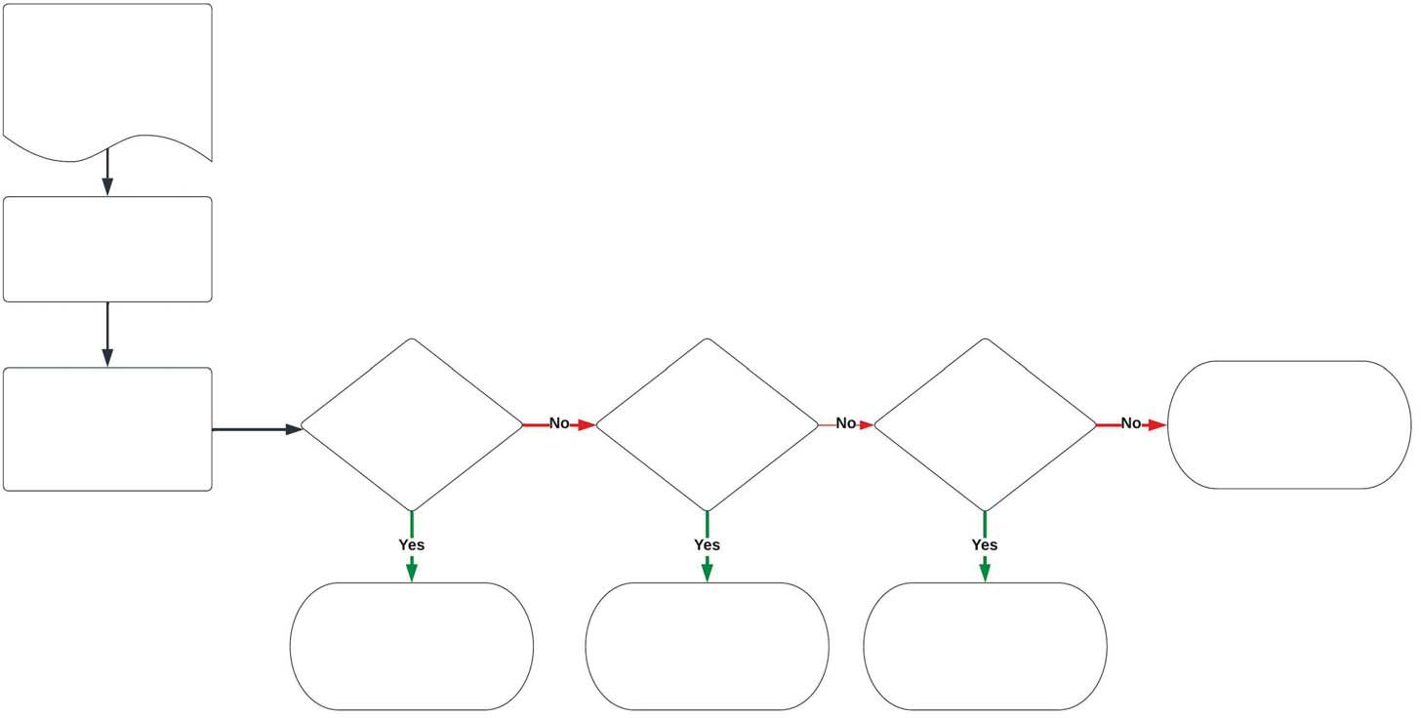
Review relevant guidance.
Undertake research to identify potential duplications.
If duplication is identified, explore options with the relevant arrangement manager(s).
Can the arrangements be
combined, or included within a current arrangement? (1)
Can one of the arrangements expire in a reasonable timeframe? (2)
When arrangements end, can agencies collaborate to avoid duplication in the future?
Review relevant guidance and explore options to manage and avoid future duplication.
Consider the contractual implications and discuss with your legal team if needed.
Allow expiry and meet business needs with retained arrangement(s).
Collaborate to establish whole-of-government arrangements that will meet all business needs.

- An example of including a specific arrangement within a whole-of-government arrangement could be to establish a “sub-arrangement” under an existing whole-of-government arrangement. A sub-arrangement might include suppliers able to deliver on additional specifications.
- Alternate options might include the potential to extend an arrangement(s) to align expiry dates before tendering a single arrangement.

Page 7 of 7

