Purpose
What do you want to learn from your research? Why is this information important and what will it inform? This will guide what data we collect and the questions we ask.
User need
Business need

Participants
Who will receive this survey? Will it be public on the For government website or sent to all Queensland Government employees on the Wired discussion list? Do you have an existing mailing list of people opted in for research or will you need to create a new list of recipients?
Recipients | ☐ For gov website | ☐Wired | ☐ Existing list | ☐New list
List
Participant identifier | ☐ Anonymous | ☐Email | ☐ Other (Please specify)

Title
Maximum of 55 characters (including spaces).

Questionnaire
Ask questions that collect accurate and relevant data. Use different question types to engage your participants. See Appendix for an explanation of question types. Follow the Queensland Government Style Manual.

Introduction text

Question 1
Question
Type | ☐ Short answer text | ☐Long answer text | ☐ Radio button | ☐Checkbox
Type | ☐ Dropdown | ☐Ranking | ☐ Matrix | ☐Likert scale
Options
Extra information | ☐ Optional | ☐ Random order | ☐ Logic (Please specify)

Question 2
Question
Type | ☐ Short answer text | ☐Long answer text | ☐ Radio button | ☐Checkbox
Type | ☐ Dropdown | ☐Ranking | ☐ Matrix | ☐Likert scale
Options
Extra information | ☐ Optional | ☐ Random order | ☐ Logic (Please specify)

Question 3
Question
Type | ☐ Short answer text | ☐Long answer text | ☐ Radio button | ☐Checkbox
Type | ☐ Dropdown | ☐Ranking | ☐ Matrix | ☐Likert scale
Options
Extra information | ☐ Optional | ☐ Random order | ☐ Logic (Please specify)

Question 4
Question
Type | ☐ Short answer text | ☐Long answer text | ☐ Radio button | ☐Checkbox
Type | ☐ Dropdown | ☐Ranking | ☐ Matrix | ☐Likert scale
Options
Extra information | ☐ Optional | ☐ Random order | ☐ Logic (Please specify)

Question 5
Question
Type | ☐ Short answer text | ☐Long answer text | ☐ Radio button | ☐Checkbox
Type | ☐ Dropdown | ☐Ranking | ☐ Matrix | ☐Likert scale
Options
Extra information | ☐ Optional | ☐ Random order | ☐ Logic (Please specify)

Subject matter expert (first level approval)
The person who provides the information and reviews the accuracy of the content.
Name
Date
Position
Organisation

Editor (second level approval)
The person who provides the editorial advice and approves the content ready for publishing online.
Name
Date
Position
Organisation

Director or equivalent approval (third level approval)
The person who approves the content to be published online.
Name
Date
Position
Organisation

Appendix

Logic
Adding logic to your survey allows a participant to skip a question based on their answers to a previous closed-ended question. You can skip to another question or to the end of the survey.

Question types

Short answer text


Long answer text
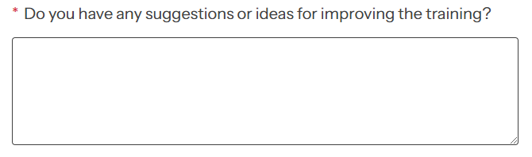

Radio button
Use when a participant can only select one item. Use a dropdown when you have a list longer than 5 items.


Checkbox
Use when a participant can select more than one item.


Dropdown
Use when you have a list longer than 5 items and when a participant needs to select only one item.


Ranking
Use when participants need to prioritise or order a list of items.
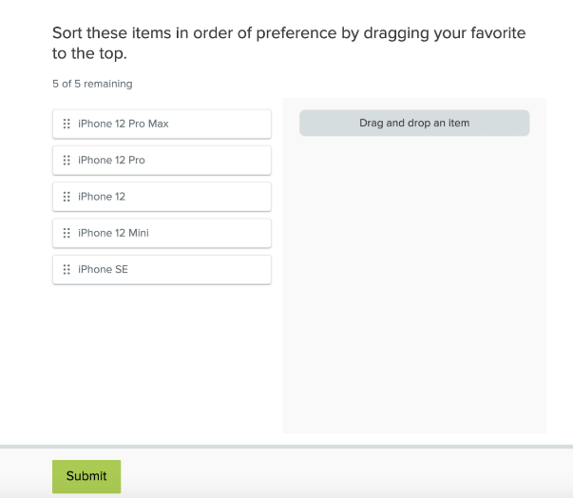

Matrix
Use to evaluate multiple items using the same set of response options.
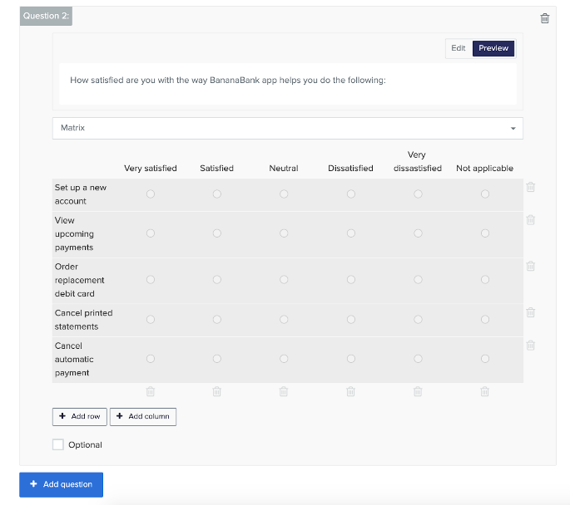

Likert scale
Use to gauge opinions across a spectrum.
