Open data portal publishing user manual for contract disclosure

  - Queensland Government Procurement

Open data portal publishing manual for contract disclosure
v3.0 July 2024

The State of Queensland (Department of Energy and Climate) 2024

http://creativecommons.org/licenses/by/4.0/deed.en
This work is licensed under a Creative Commons Attribution 4.0 Australia Licence. You are free to copy, communicate and adapt this work, as long as you attribute by citing ‘Open data portal publishing manual for contract disclosure, State of Queensland (Department of Energy and Climate) 2024.
Contact us
Queensland Government Procurement is committed to continuous improvement. If you have any suggestions about how we can improve this guide, or if you have any questions, contact us at betterprocurement@epw.qld.gov.au.
Disclaimer
This document is intended as a guide only for the internal use and benefit of government agencies. It may not be relied on by any other party. It should be read in conjunction with the Queensland Procurement Policy, your agency’s procurement policies and procedures, and any other relevant documents.

The Department of Energy and Climate disclaims all liability that may arise from the use of this document. This guide should not be used as a substitute for obtaining appropriate probity and legal advice as may be required. In preparing this document, reasonable efforts have been made to use accurate and current information. It should be noted that information may have changed since the publication of this document. Where errors or inaccuracies are brought to attention a reasonable effort will be made to correct them.
Table of Contents
1 Terms and definitions 4
2 Background 5
3 Purpose of this publication 5
4 Scope 6
4.1 Included 6
4.2 Excluded 6
4.3 Assumptions 6
4.4 Publishing requirements 6
5 Roles and responsibilities 6
5.1 QGP responsibilities 6
5.2 Agency responsibilities 6
5.3 Smart Service Queensland responsibilities 7
6 Information dataset 8
6.1 Data disclosure fields 8
7 Process to prepare contract disclosure reports 13
8 Data field clarifications 13
8.1 Data publisher name 13
8.2 Agency address 13
8.3 Variation of contract 13
8.4 Category group 13
8.5 Procurement method 14
8.6 Reason for use of limited tendering 14
9 Data update process and tools 15
9.1 New contract disclosure process 15
9.2 New detailed contract disclosure publishing process 16
9.3 Specific technical requirements 17
9.4 Formatting 17
9.5 Reference material and contacts 18
10 Publishing to the open data portal 18

1 Terms and definitions
Abbreviations | Descriptions
Agency/Agencies | For the purpose of this guide means budget sector agencies, departments, large statutory bodies and special purpose vehicles
Construction Services | The definition of ‘construction services’ for the purposes of contract disclosure is aligned to the Commonwealth Procurement Rules (Section 9.7)  Construction services – procurements related to the construction of buildings and procurements of works as defined by the Public Works Committee Act 1969 (Cth) and State Development and Public Works Organisation Act 1971 (Qld).
CPTPP | Comprehensive and Progressive Agreement for Trans-Pacific Partnership
CSV | Comma Separated Value. A plain text format data file using commas (,) as separator. This is the required file format for affected entities to upload their data to open data portal
FTA | Free-Trade Agreements are international treaties between Australia and one or multiple economies with the objective to reduce and eliminate barriers to international trade and investment.
ICT | Information and Communications Technology
KDS | Key Data Set
Limited | This is a procurement method where the agency invites a supplier/s of its choice to offer.  Limited tenders usually only occur in very specific circumstances, such as under states of emergency or if goods and services can only genuinely be provided by one supplier (e.g. where a supplier holds exclusive rights/patents for an essential good). Other terms sometimes used to refer to a ‘limited offer method’ include sole supply, sole source, single sourcing, and direct supply.  For clarity, a ‘limited offer method’ does not necessarily include directly approaching a supplier from an arrangement already established (see Section 1.5 of the Procurement Guidelines: Contract Disclosure).
OCDS | Open Contracting Data Specifications. The Open Contracting Data Standard (OCDS) enables disclosure of data and documents at all stages of the contracting process by defining a common data model.  It was created to support organisations to increase contracting transparency and allow deeper analysis of contracting data by a wide range of users.  The Open Contracting Data Standard is a core product of the Open Contracting Partnership (OCP).  Version 1.0 of the standard was developed for the OCP by the World Wide Web Foundation, through a project supported by the Omidyar Network and the World Bank. Ongoing development is managed by Open Data Services Co-operative under contract to OCP.  More information can be found here: http://standard.open-contracting.org/latest/en/
Open | This is a procurement method where all interested suppliers may submit an offer.  For example, an open tender is an ‘open offer method’. In addition, common-use supply arrangements as defined in the QPP, including standing offer arrangements and panels, will usually be established via an open tender (where any interested supplier may submit an offer to be on the arrangement/panel).
QGP | Queensland Government Procurement
QPP | Queensland Procurement Policy
Selective | This is a procurement method where suppliers that have met pre-established criteria are invited to offer.  For example, suppliers may be required to hold a certain qualification, accreditation, certification or licence that is relevant to the good/service being procured. Arrangements that may be ‘selective’ include:  - pre-registration processes/systems  - Pre-Qualification System (PQC)

2 Background
Clause 31 of the Queensland Procurement Policy (QPP) requires budget sector agencies, large statutory bodies and special purpose vehicles (agencies) to publish certain information about awarded contracts valued at $10,000 and over.
This manual assists agencies to publish this information on the Open Data website. It should be read together with the Procurement Guidelines: Contract Disclosure document and the guide Use and disclosure of confidentiality provisions in government contracts.

3 Purpose of this publication
The purpose of this user manual is to assist agencies to disclose details of the awarded contracts as required by clause 31 of the QPP and to provide step-by-step instructions and supporting documentation to representatives of agencies for the publishing of contract disclosure data to the open data portal. The following information is included in this document:
- mapping existing data structures to new data structures for contract disclosure
- step-by-step guide to disclose contracts valued at $10,000 and over in accordance with the QPP and data specifications
- guidance to disclose limited procurement method contracts
- specific technical requirements to upload the data file to open data portal.

4 Scope

4.1 Included
- Detailed information on publishing requirements and a suggested decision tree to assist with the contract disclosure process.
- Technical information on data specifications and related information to publish data on the open data portal.

4.2 Excluded
- Specific technical ICT user guide on how to use a PC and internet browsers.
- Specific technical ICT user guide on how to access the open data portal.

4.3 Assumptions
This guide assumes the following:
- users are familiar with the disclosure requirements in the QPP and the Procurement Guidelines: Contract Disclosure (the Guidelines).
- agencies are aware of Queensland Government’s open data portal and can access this website.
- users within agencies can access the open data portal and know how to use internet browser.

4.4 Publishing requirements
Agencies must have a dataset custodian who is responsible for creating and publishing the required dataset resource on the open data portal.
The custodian will require a self-publishing account to publish contract disclosure datasets on the open data portal. A new account should be requested via an online form at: https://www.forgov.qld.gov.au/request-publishing-access-data-and-publications-portals.
This data is loaded and updated using the instructions found in Appendix A, Publishing to the open data portal.

5 Roles and responsibilities

5.1 QGP responsibilities
QGP is responsible for custodianship and management of the QPP and the Guidelines, specifically:
- coordinating the identification and implementation of updates to the QPP, the Guidelines and publishing user manual
- providing templates and instructions about contract disclosure
- consulting with agency representatives on any global changes required.

5.2 Agency responsibilities
Each agency is responsible for:
- allocating dedicated resources to prepare, validate and cleanse the data to meet specific publishing requirements and publish their contract disclosure updates in line with the QPP and the Guidelines. It is strongly recommended that all agencies have a resource trained to backfill when required
- collecting data and creating the Comma separated value (CSV) file and uploading to open data as outlined in Section 9, to prepare contract disclosure reporting. Data should be refreshed periodically in line with QPP and the Guidelines. Data is to be approved by each agency’s relevant governance body or delegate prior to refreshing
- refreshing the data in the production environment (i.e. open data)
- cross-checking the accuracy of the contract disclosure data loaded to open data in the production environment following each refresh
- retaining a copy of each dataset on the agency’s own network drive or electronic documents records management system to provide a historical record or for right to information requests. Only the current resources will be available in open data
- responding to any media requests for their agency’s contract disclosure, which are displayed on the contract disclosure open data portal.

5.3 Smart Service Queensland responsibilities
Smart Service Queensland is responsible for:
- providing assistance to agencies, as required, to identify and resolve any open data platform related issues for future refreshes
- investigating non-urgent issues and to respond within three working days
- investigating urgent requests where there are extenuating circumstances
- implementing changes to the data attributes as requested by QGP, following consultation with the agencies
- updating static global data as requested by QGP.

6 Information dataset

6.1 Data disclosure fields
The following table provides data field names and short descriptions of the information provided for the contract disclosure dataset and how each field maps to Procurement Key Data Sets (KDS) and the international, open standard Open Contracting Data Standard (OCDS).
Contract disclosure fields
Legend
Mandatory for contracts over $10,000
Mandatory for contracts over $500,000 additional field to complete
Mandatory for goods and services contracts over $500,000 and construction contracts over $8.5 million additional field to comply with FTA obligations
Mandatory for contracts over $10 million additional fields to complete
Optional fields recommended for comprehensive recordkeeping
OCDS name | KDS | Contract disclosure field name | Description | Status | Type | Comment
 |  | Agency | Name of agency | Mandatory | Text
 |  | Agency address | The address of the agency procuring the services | Mandatory | Text | For multiple addresses, separate each address using the semi-colon (;) character. For example: Address 1; Address 2; Address 3
Contracts/title | Contract name | Contract description/name | Short name for purpose of contract e.g. "Cleaning for Nambour customer service centre” | Mandatory | Text
Contracts/date signed | Contract | Award contract date | Date contract was awarded to the supplier | Mandatory | Date | DD/MM/YYYY
Contracts/value/amount | Executed contract value | Contract value | Dollar value of the contract at the time the contract is signed (executed) | Mandatory | Number | $Value of the contract
Parties additional identifiers/id | Not assessed | Supplier name | Registered business name (e.g. legal name as per the contract) | Mandatory | Text
Parties/address | Not assessed | Supplier address | Street address of the office where the supplier is based | Mandatory | Text | For multiple addresses, separate each address using the semi-colon (;) character. For example: Address 1; Address 2; Address 3
 |  | Variation to Contract | Identify if the item is a variation to the original contract | Mandatory | Drop down list | REQUIRED  Yes/No
 |  | Specific confidentiality provision used | A specific confidentiality provision has been included in the contract | Mandatory | Drop down list | REQUIRED  Yes/No
Tender procurement method | Contract type | Procurement method |  | Additional fields only required for contracts over $500,000 | Drop down list | REQUIRED  Refer to the list in section 8.5  Can only be - Open, selective or limited
 |  | Reason for use of limited tendering | Providing an FTA compliant reason for use of a limited procurement method of tendering | Additional field only for contracts:  - Goods and services valued >$500,000  - Construction services valued >$8.5 million | Drop down list | REQUIRED  Refer to the list in section 8.6
 |  | Form of contract |  | Additional fields only required for contracts over $10 million | Text | As required
 |  | Number of offers |  | Additional fields only required for contracts over $10 million | Text | As required
 |  | Evaluation criteria and weightings |  | Additional fields only required for contracts over $10 million | Text | As required
 |  | Deliverables |  | Additional fields only required for contracts over $10 million | Text | As required
 |  | Contract milestones |  | Additional fields only required for contracts over $10 million | Text | As required
 |  | Contract performance management |  | Additional fields only required for contracts over $10 million | Text | As required
Contracts/award ID | Tender number | Contract reference number | Agency’s specific identifier/number which uniquely identifies the contract within the agency e.g. TMR5516 | Optional | Text
Contracts/items/classification/description | Contract group | Contract category group | Classification of the transaction into one of six (6) Qld government category groups | Optional | Drop down list | Refer to the list of contract category groups in section 8.4
Contracts | Contracts | Parent contract number/SOA | Parent contract number if one exists | Optional | Text | A list of additional / supplemental identifiers for the organisation or participant, using the organisation identifier guidance. This could be used to provide an internally used identifier for this organisation in addition to the primary legal entity identifier.
Contracts/period/start date | Planned commencement date | Commence date | Date supplier is expected to commence activity as stipulated in the contract | Optional | Date | DD/MM/YYYY
Parties/identifier/URI | Not assessed | Supplier ABN | If ABN or ACN is known | Optional | Text
Contracts/period/end date | Planned finish date | Finish date | Date supplier expected to complete activity as stipulated in the contract | Optional | Date | DD/MM/YYYY

7 Process to prepare contract disclosure reports
Agencies are responsible for managing their contract disclosure reporting and uploading to the open data portal. The following provides the steps required to prepare contract disclosure data:
- Refer to the Procurement Guidelines: Contract Disclosure for details on requirements to create your CSV file.
- Each financial year, create your financial year file in accordance with, 9.2 New detailed contract disclosure publishing process and 9.3 Specific technical requirements.
- This file is updated (appended to) monthly, as specified in the contract disclosure guideline, and refreshed on the Open Data Portal.
- At the end of each financial year the last period is reported, and the file is closed off and retained on the Open Data Portal.
- As each new financial year starts a new file is created and the process repeats.
Agencies must have a custodian with access to the open data portal to manage all uploads. Refer to Section 10 for details.
Agencies must retain copies of financial year disclosure reports for their records and be able to make them available if requested for audit and review.

8 Data field clarifications
This section provides further clarification about the type of information supplied.

8.1 Data publisher name
Full name of the agency that published the dataset.

8.2 Agency address
The agency’s physical address should be in the following format:
- unit/building number (if relevant)
- street number
- street name
- street Address
- suburb
- postcode
- state

8.3 Variation of contract
Identify if the item is a variation to the original contract.
- Yes
- No

8.4 Category group
This refers to the Queensland Government procurement six category groups as follows:
- Building Construction and Maintenance
- General Goods and Services
- Information and Communication Technology
- Medical
- Social Services
- Transport Infrastructure and Services.

8.5 Procurement method
Procurement method that was used for all contracts valued at $500,000 and above, restricted to the following definitions:
- Open
- Selective
- Limited

8.6 Reason for use of limited tendering
Rationale for use of a limited procurement method for tendering as required to meet FTA obligations, as extracted directly from Chapter 15.10 Section 2 of the CPTPP.
A procuring entity may use limited tendering only under the following circumstances:
- if, in response to a prior notice, invitation to participate or invitation to tender:
- no tenders were submitted or no suppliers requested participation;
- no tenders were submitted that conform to the essential requirements in the tender documentation;
- no suppliers satisfied the conditions for participation; or
- the tenders submitted were collusive,
provided that the procuring entity does not substantially modify the essential requirements set out in the notices or tender documentation;
- if the good or service can be supplied only by a particular supplier and no reasonable alternative or substitute good or service exists for any of the following reasons:
- the requirement is for a work of art;
- the protection of patents, copyrights or other exclusive rights; or
- due to an absence of competition for technical reasons;
- for additional deliveries by the original supplier or its authorised agents, of goods or services that were not included in the initial procurement if a change of supplier for such additional goods or services:
- cannot be made for technical reasons such as requirements of interchangeability or interoperability with existing equipment, software, services or installations procured under the initial procurement, or due to conditions under original supplier warranties; and
- would cause significant inconvenience or substantial duplication of costs for the procuring entity;
- for a good purchased on a commodity market or exchange;
- if a procuring entity procures a prototype or a first good or service that is intended for limited trial or that is developed at its request in the course of, and for, a particular contract for research, experiment, study or original development. Original development of a prototype or a first good or service may include limited production or supply in order to incorporate the results of field testing and to demonstrate that the prototype or the first good or service is suitable for production or supply in quantity to acceptable quality standards, but does not include quantity production or supply to establish commercial viability or to recover research and development costs. Subsequent procurements of these newly developed goods or services, however, shall be subject to this Chapter;
- if additional construction services that were not included in the initial contract but that were within the objectives of the original tender documentation have, due to unforeseeable circumstances, become necessary to complete the construction services described therein. However, the total value of contracts awarded for additional construction services may not exceed 50 per cent of the value of the initial contract;
- for purchases made under exceptionally advantageous conditions that only arise in the very short term, such as from unusual disposals, liquidation, bankruptcy or receivership, but not for routine purchases from regular suppliers;
- if a contract is awarded to the winner of a design contest, provided that:
- the contest has been organised in a manner that is consistent with this Chapter; and
- the contest is judged by an independent jury with a view to award a design contract to the winner; or
in so far as is strictly necessary if, for reasons of extreme urgency brought about by events unforeseeable by the procuring entity, the good or service could not be obtained in time by means of open or selective tendering.

9 Data update process and tools

9.1 New contract disclosure process

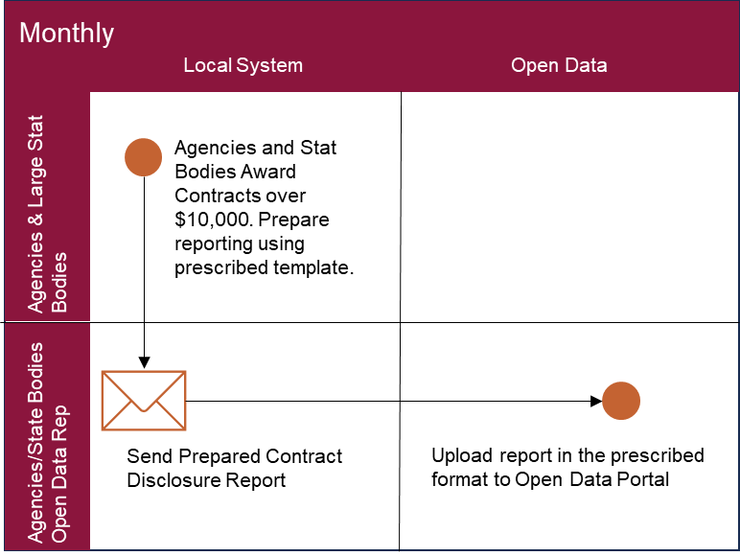

9.2 New detailed contract disclosure publishing process

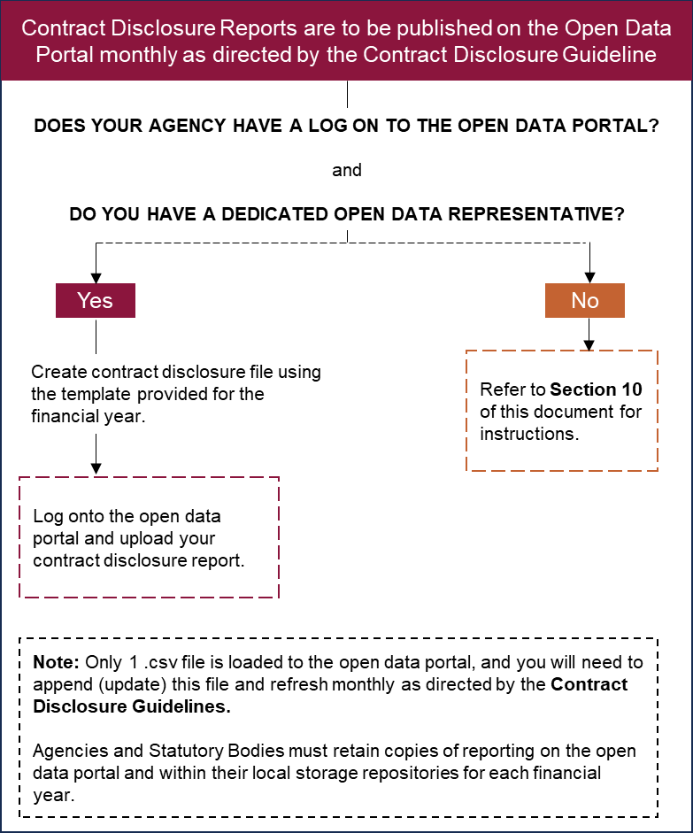

9.3 Specific technical requirements
# | Category | Requirements | Comments
1 | Data file format | Comma separated values (CSV) | Please ensure that all data fields are enclosed with double quotes before each comma separator e.g.  “Agency 1”, “Delivery address 1”, “CONS111”
2 | Data file size limit | 200MB per file | File size cannot exceed 200MB per financial year.
3 | Data file naming convention | Financial Year_Agency Name_Contract disclosure report | Financial Year_Agency name_Contract disclosure report
4 | Dataset write mode | Append to file until end of financial year | There must only one contract disclosure file per financial year which will be created each new financial year using the prescribed file naming convention. Through-out the financial year the file will be updated or added with new information.
5 | Data upload frequency | As per QGP contract disclosure guideline
6 | Open data tag/group | Contract disclosure | Data file must be uploaded using this data tag/group to ensure that it can be easily searched and grouped on open data portal
7 | Dataset custodian | Agency
8 | Information classification | Public

9.4 Formatting
The following formatting requirements must be met when compiling this data:
- minimise the use of capital letters
- use the correct date number format in the cell, DD/MM/YYYY (ensure your locale/location is set to English (Australia))
- do not use the % symbol in cells
- do not use commas in numeric cells (e.g. 1000000 not 1,000,000 or 1 000 000.00)
- use whole numbers only, not fractions or decimals
- do not change the heading row in the template
- remove hidden white spaces from the rows of files:
  - select the first empty new row by clicking on the row number
  - press ctrl+shift+down arrow - this will select everything after your last row with data
  - press delete - this will clear any hidden whitespaces
- remove hidden white spaces from the columns of files:
  - select the first empty new column by clicking on the column letter
  - press ctrl+shift+right arrow - this will select everything after your last column with data
  - press delete - this will clear any hidden whitespaces

- adhere to the QGov online resource formatting requirements available via the open data publishing standards site - https://publications.qld.gov.au/dataset/publishing-standards-data- qld-gov-au.

9.5 Reference material and contacts
- Contract disclosure data publishing template:
  - For data template please visit the following website: https://www.forgov.qld.gov.au/__data/assets/excel_doc/0033/513699/contract-disclosure-template.xlsx

- Where can I find more information about the contract disclosure requirements and open data?
- For more information about the policy requirements, please visit the following website: https://www.forgov.qld.gov.au/procurement-policy
- For more information about contract disclosure please visit the following website: https://www.forgov.qld.gov.au/procurement-guides
- For more information about open data please visit the following website: https://www.data.qld.gov.au/article/standards-and-guidance/publishing-guides-standards/open-data-portal-publishing-guide
https://www.data.qld.gov.au/article/standards-and-guidance/strategies
- Where can I get help?
- For policy requirements and contract disclosure related enquiries please email: betterprocurement@hpw.qld.gov.au
- For open data related questions please use the contact form:
https://data.qld.gov.au/article/contact.

10 Publishing to the open data portal
The following details and links provide instruction on how affected entities can publish contract disclosure reports to the open data portal on both the staging and production sites. Users must be authorised to publish to the open data portal.
Remember that all white space must be removed, certain symbols such as percent signs and commas in number columns are not permitted, and there is only one .csv file involved: Agency/stat body name_Contract disclosure report.
Please note, that on open data, the dataset will still be called Agency/stat body name_Contract disclosure report.
Following are the links to the open data portals and how to obtain your username and password.
Data portal:
Training site: https://staging.data.qld.gov.au/user/login
Live site: http://data.qld.gov.au/user/login.
Publications portal:
Training site: https://staging.publications.qld.gov.au/user/login
Live site: http://publications.qld.gov.au/user/login.
If you do not have a username or password, contact the Online Products Team. (onlineproducts@smartservice.qld.gov.au).
For detailed instructions on entering data into the open data portal, please refer to the process guide.
For further information on open data standards and formatting guides visit publishing standards.

All dollar values referred to in this guideline are inclusive of GST.

