Planning your HCD approach checklist

HCD in Queensland Government

Use this checklist to address each phase of the HCD approach, determine the activities appropriate to your project, and where support is required.

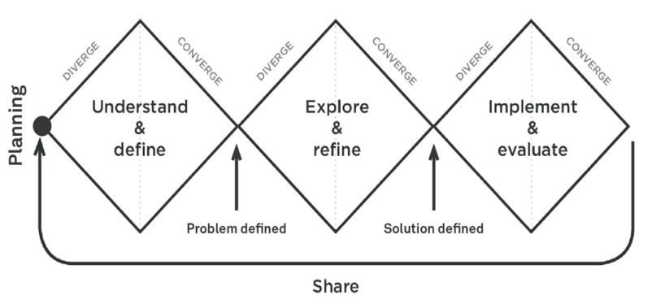

Planning

Mark when done | Activity | Blockers | Additional support required
 | Set up a project space/wall/online space (Miro is a great option) for collaborative working and sharing with stakeholders.

Understand phase

Define and understand

Mark when done | Activity | Blockers | Additional support required
 | Clearly identify and articulate the design challenge.
 | Clearly define the audience - the people involved or effected.
 | Identify and digest relevant secondary research that may already exist.

Plan research

Mark when done | Activity | Blockers | Additional support required
 | Identify with whom you will conduct research.
 | Identify the appropriate research method(s).
 | Plan the research activities, equipment, materials and logistics.
 | Recruit participants for research.

Conduct research

Mark when done | Activity | Blockers | Additional support required
 | Conduct research with customers to understand the problem space.
 | Write up research notes and observations.

Analysis and synthesis

Mark when done | Activity | Blockers | Additional support required
 | Analyse and synthesise the research findings into themes and insights.

Articulate the research findings

Mark when done | Activity | Blockers | Additional support required
 | Identify who you need to communicate the research findings to
 | Articulate your research findings and share

Define phase

Redefine and prioritise

Mark when done | Activity | Blockers | Additional support required
 | Identify and prioritise opportunities
 | Refine or redefine the problem to be solved by creating well defined problem statements

Determine success criteria

Mark when done | Activity | Blockers | Additional support required
 | Identify what the success criteria of a potential solution should be

Explore and refine

Concept generation

Mark when done | Activity | Blockers | Additional support required
 | Generate multiple concepts to solve the problem

Prioritise and test

Mark when done | Activity | Blockers | Additional support required
 | Prioritise the concepts to be tested
 | Plan prototyping activities and recruit participants
 | Iteratively prototype, test, and refine the concepts to narrow in on a solution

Communicate the vision

Mark when done | Activity | Blockers | Additional support required
 | Define the purpose and audience for communicating the vision for the solution
 | Articulate your research findings and share

Implement and evaluate

Plan and implement the solution

Mark when done | Activity | Blockers | Additional support required
 | Prioritise and roadmap the elements and features of the solutions
 | Create detailed designs
 | Conduct time, budget, and resource planning and estimates for implementation
 | Implement

Evaluate and iterate

Mark when done | Activity | Blockers | Additional support required
 | Evaluate the impact
 | Iterate the solution

Share

Mark when done | Activity | Blockers | Additional support required
 | Share the research insights and outputs
 | Share your project approach

